

**Prose Style Transfer – Help Page**

# Made By – Din Golan & Matan Peer

**If is your first time at our application, WELCOME!**

# Important Note –

**In our system we have two different default models.  
The first default model call – ‘Model_With_Augmentation.h5’.  
The second default model call – ‘Model_Without_Augmentation.h5’.  
This is important note because, if you don’t want to wait for creating the model (Process that take approximately between 2 – 4 hours), you can run one of those default models.   
The path of those models locates in folder that call ‘Model\Default – Model’, and this folder (‘Model’) locate in the same folder that the ‘.exe’ file of the program locate.   
Note – The path of those default models is written automatically in the code, so you don’t need to worry about the location of those default models.**

# Explanations About the Application –

## Start Window –

* **‘Combo Box’ –**
* **This combo box contains the roles in our system.**
* **The roles that we have in the system is –**
* **User.**
* **Manager.**
* **‘Start Button’ –**
* **With this you will start the process of the system according to the role that you choose.**
* **‘Help Button’ –**
* **With this button you will get instructions about the system.**
* **In addition, you will get explanations about each button in each window in the system.**
* **‘Exit Button’ –**
* **With this button you will exit from the system.**

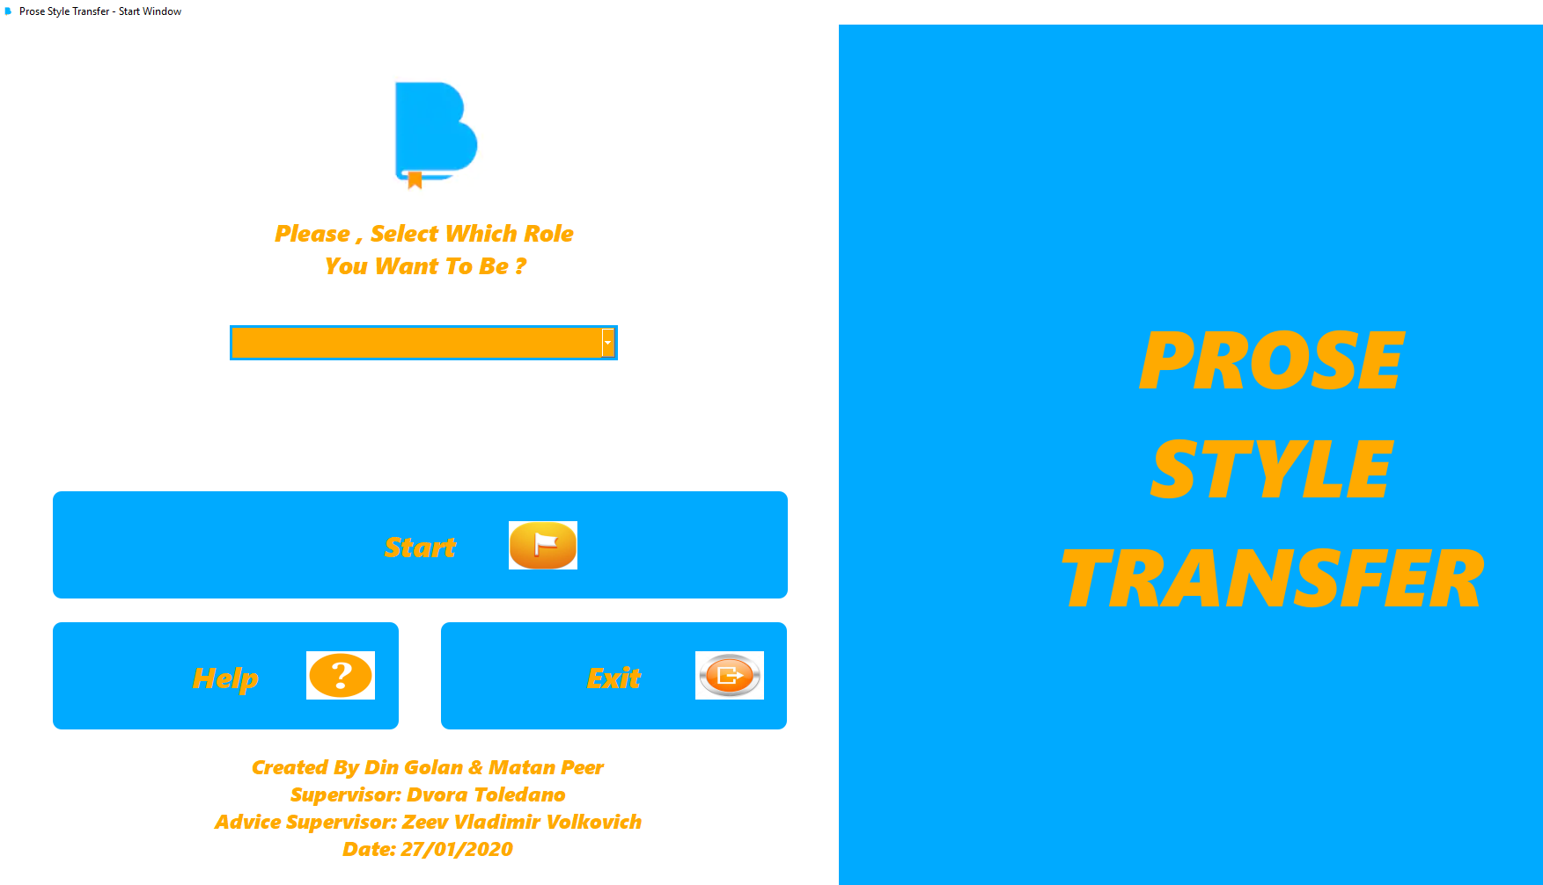

## User Window –

* **Important Note –**
* **You must select role in our system.**
* **‘Model Without Data Augmentation’ –**
* **With this button you will run model without data augmentation, it’s mean model that will not change the words to their synonyms.**
* **The unchanging of the words to their synonyms will not effect on the accuracy of the compressions between the versions that the user pick.**
* **‘Model With Data Augmentation’ –**
* **With this button you will run model with data augmentation, it’s mean model that will change the words to their synonyms.**
* **The changing of the words to their synonyms will effect on the accuracy of the compressions between the versions that the user pick.**
* **‘Back Button’ –**
* **With this button you will back to the previous window.**
* **The previous window from here is – ‘Start Window’.**
* **‘Help Button’ –**
* **With this button you will get instructions about the system.**
* **In addition, you will get explanations about each button in each window in the system.**

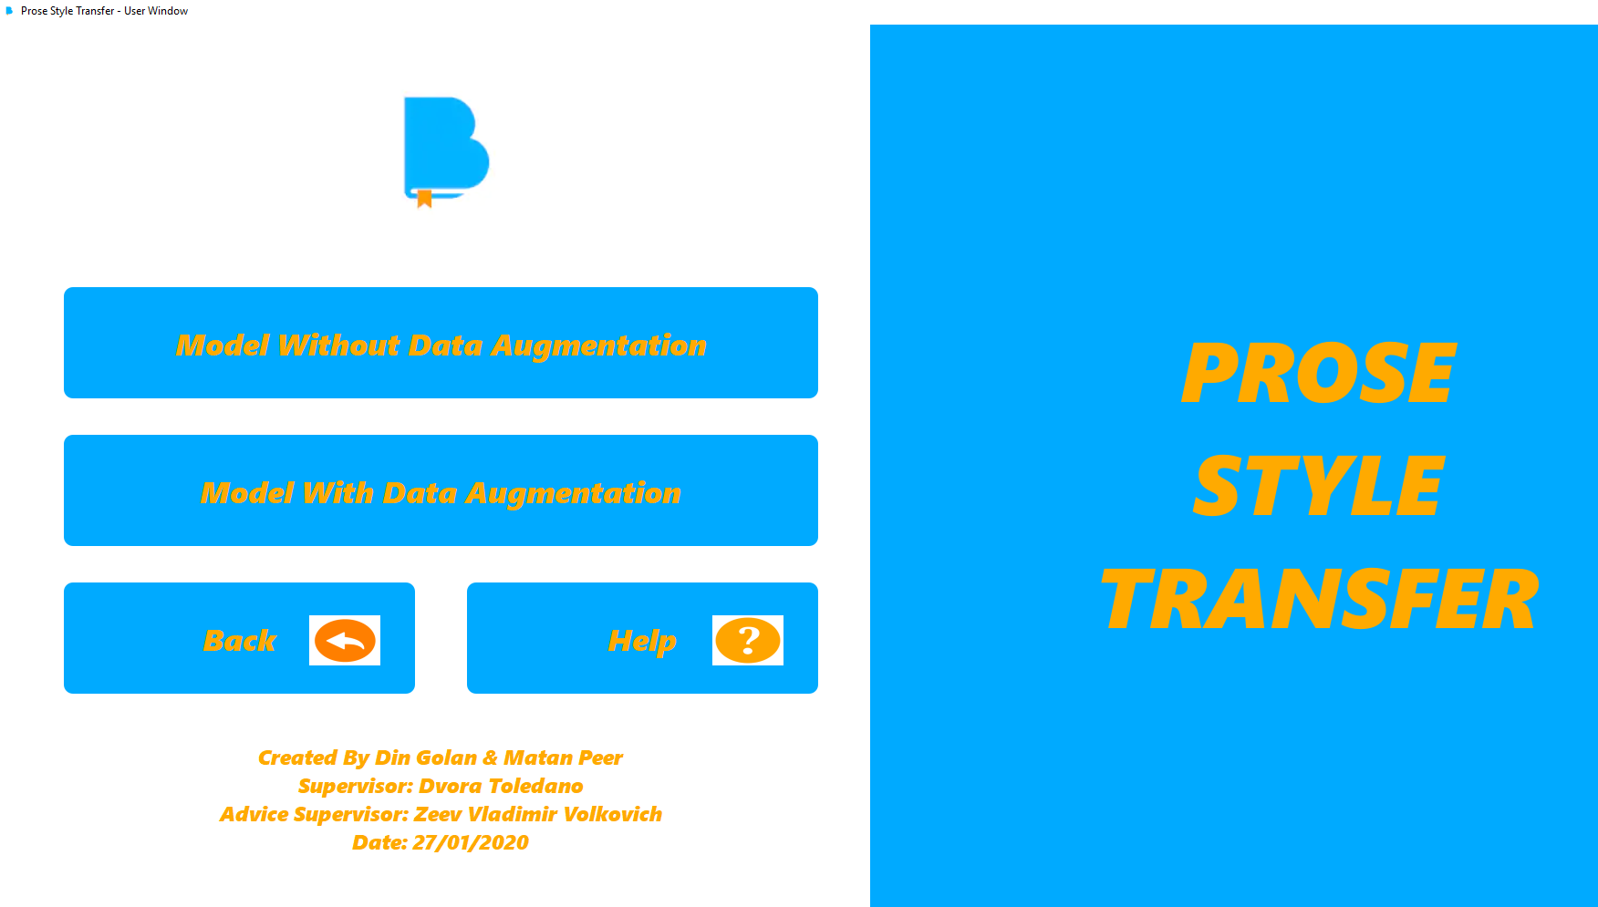

## Manager Window -

* **Important Note –**
* **You must select role in our system.**
* **‘Model Without Data Augmentation’ –**
* **With this button you will run model without data augmentation, it’s mean model that will not change the words to their synonyms.**
* **The unchanging of the words to their synonyms will not effect on the accuracy of the compressions between the versions that the user pick.**
* **‘Model With Data Augmentation’ –**
* **With this button you will run model with data augmentation, it’s mean model that will change the words to their synonyms.**
* **The changing of the words to their synonyms will effect on the accuracy of the compressions between the versions that the user pick.**
* **‘Settings Button’ –**
* **This button is visible only for the manager.**
* **The manager can change settings that belongs to the model.**
* **The settings are – Epoch Number, Batch Size, Training Split.**
* **These parameters belongs to function that call – ‘model.fit’.**
* **They can change two main things –**
* **The accuracy of the model results, The creation time of the model.**
* **‘Back Button’ –**
* **With this button you will back to the previous window.**
* **The previous window from here is – ‘Start Window’.**
* **‘Help Button’ –**
* **With this button you will get instructions about the system.**
* **In addition, you will get explanations about each button in each window in the system.**

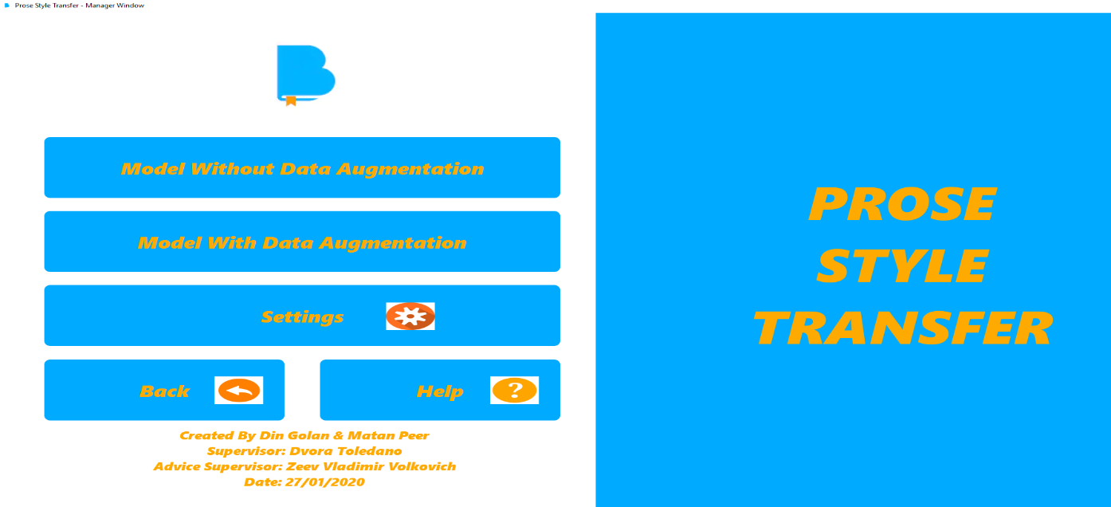

## Settings Window –

* **‘Epoch Number’ –**
* **If you are manager, you can select the number of the epochs.**
* **This parameter is for internal function of the model that call – ‘model.fit’.**
* **‘Batch Size’ –**
* **If you are manager, you can select the size of the batch.**
* **This parameter is for internal function of the model that call – ‘model.fit’.**
* **‘Training Split’ –**
* **If you are manager, you can select the size of the training split.**
* **This parameter is for internal function of the model that call – ‘model.fit’.**
* **‘Back Button’ –**
* **With this button you will back to the previous window.**
* **The previous window from here is – ‘Manager Window’.**
* **‘Help Button’ –**
* **With this button you will get instructions about the system.**
* **In addition, you will get explanations about each button in each window in the system.**
* **‘Apply Button’ –**
* **With this button you will save the parameters that you pick as manager.**
* **Those parameters will be used in internal function that belong to the model.**
* **The internal function call – ‘model.fit’.**
* **Note – if you press apply, and you don’t change any settings, you will get message box that give you the opportunity to use with the default parameters of the system.**
* **The Default Parameters Is –**
* 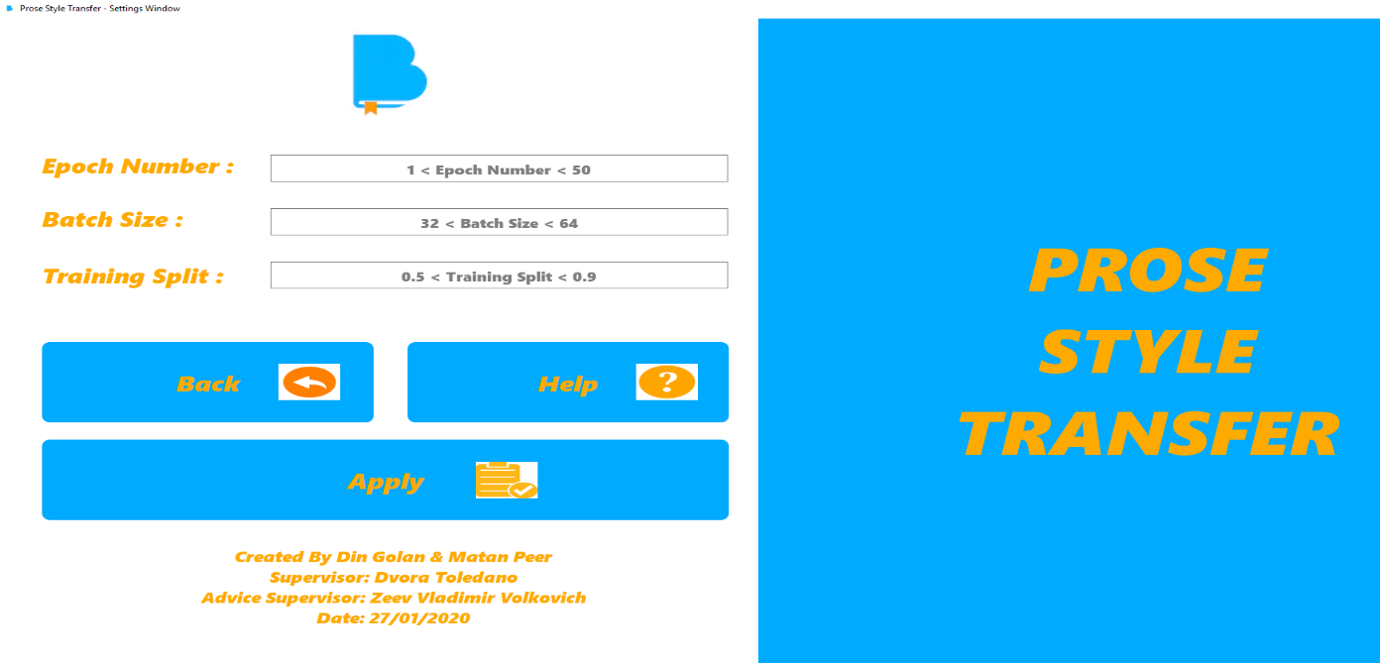**Epoch Number – 10, Batch Size – 64, Training Split – 0.7**

## Select Source & Target Window –

* **‘Select First Version’ –**
* **You need to select source version of bible.**
* **In our system, there have a big data set that include a lot of versions of bibles, and from this big data set the user need the select his first bible version.**
* **The user make this choice because he need to make compressions between the first version that he select and the second version that he select.**
* **‘Select Second Version’ –**
* **You need to select target version of bible.**
* **In our system, there have a big data set that include a lot of versions of bibles, and from this big data set the user need the select his second bible version.**
* **The user make this choice because he need to make compressions between the first version that he select and the second version that he select.**
* **‘Back Button’ –**
* **With this button you will back to the previous window.**
* **The previous window from here is – ‘Manager Window’ or ‘User Window’.**
* **We return to previous window according to the Role that you pick (User / Manager).**
* **‘Help Button’ –**
* **With this button you will get instructions about the system.**
* **In addition, you will get explanations about each button in each window in the system.**
* **‘Run Model’ –**
* **With this button you will start the first phase of ‘Running the model’.**
* 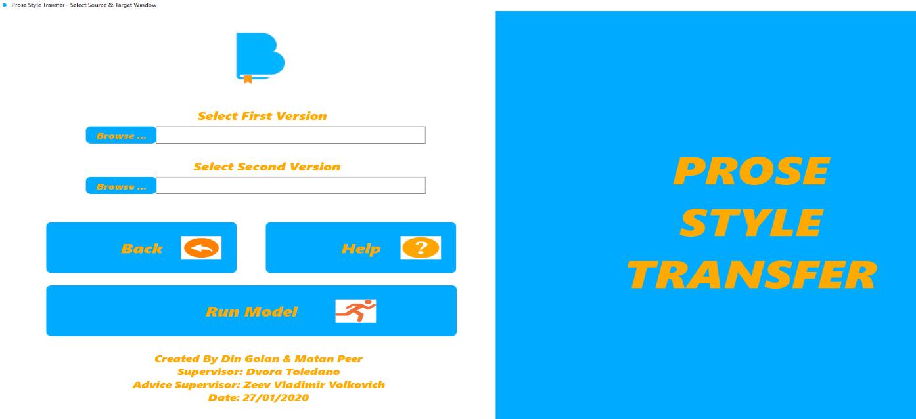**The first phase is to check if the model exist in the system.**

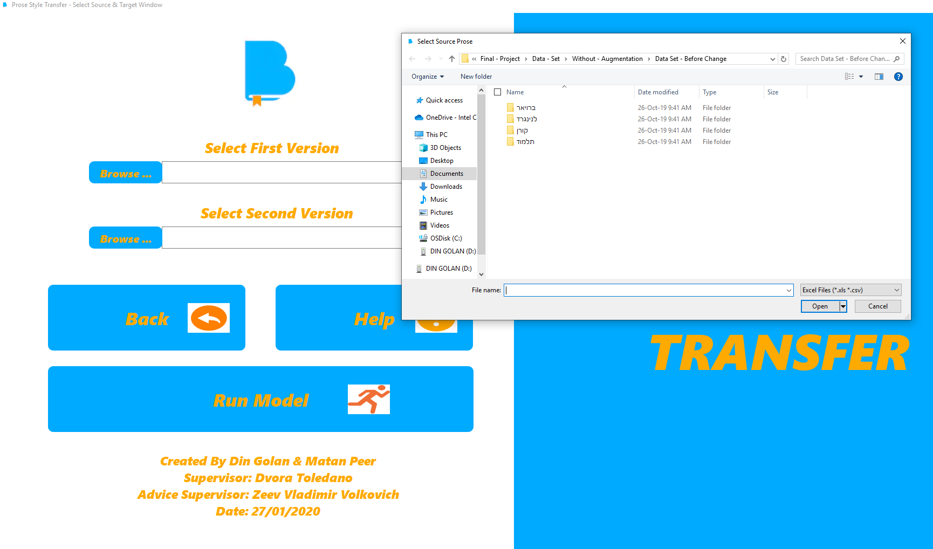

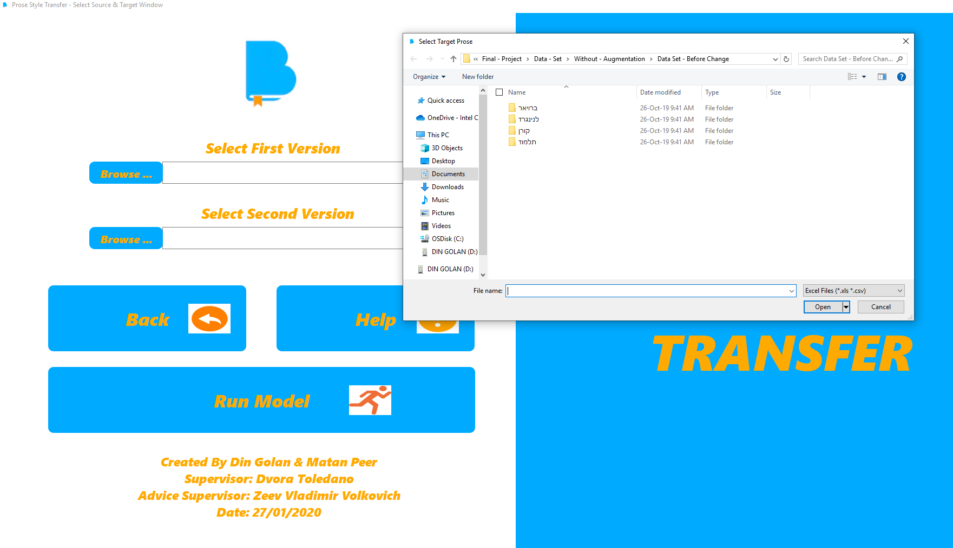

## Progress Window –

* **‘Predict Button’ –**
* **With this button you make the prediction of the model.**
* **The prediction phase can be done only if the model exist.**
* **If you are user, you have 3 options –**
* **Make predict to the results of the new model that exist in the system (This new model created by the manager).**
* **Make predict to the results of the default model that exist in the system, because we don’t have new model in the system.**
* **Can’t make predict to the results of the model, because there no have new model that exist in the system, and as user you don’t want to run the default model that exist in the system.**
* **‘Progress Bar’ –**
* **This progress bar will represent for the user / manager the promotion of the production function of the model.**
* **The range of this progress bar is between 0% - 100%.**
* **‘Back Button’ –**
* **With this button you will back to the previous window.**
* **The previous window from here is – ‘Select Source & Target Window’.**
* **‘Help Button’ –**
* **With this button you will get instructions about the system.**
* **In addition, you will get explanations about each button in each window in the system.**

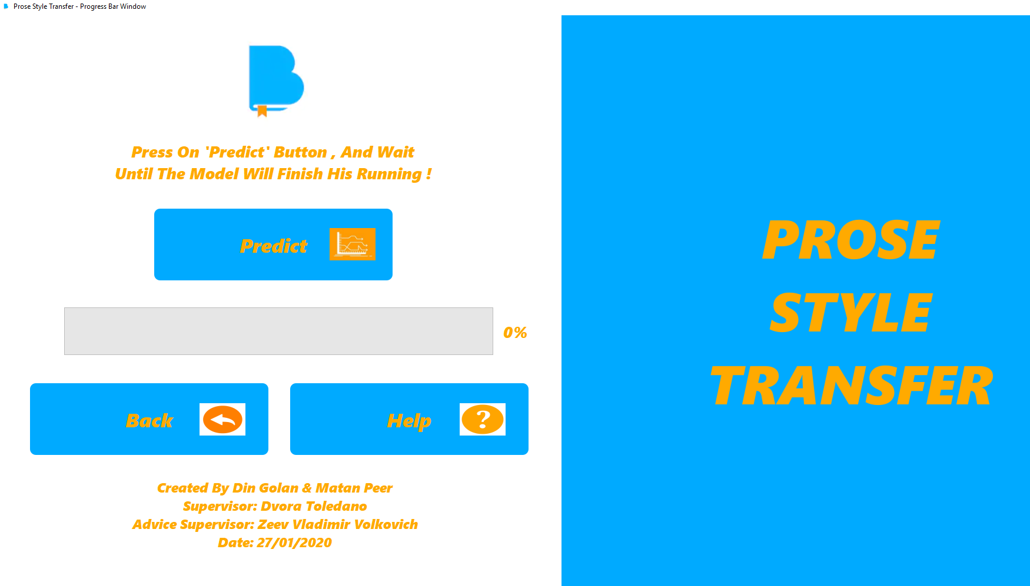

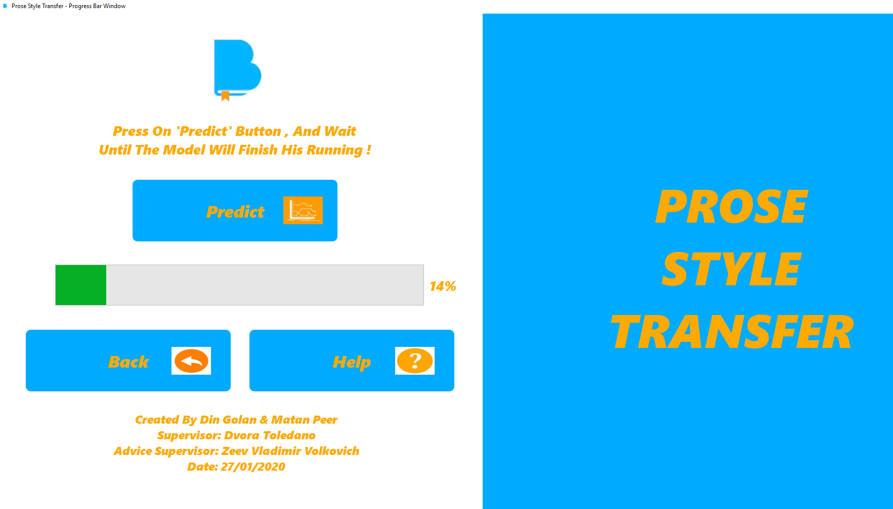

## Create Model Window –

* **‘Build Model’ –**
* **With this button you will build new model.**
* **If there no have any new models in the system, you must as manager to create new models for the system.**
* **Furthermore, if you want to make prediction in the next phase, you must to create new model for the system.**
* **The new model will get the parameters that the managers fill in the ‘Settings Window’, or the new model will get the default settings that we have in the system.**
* **‘Continue To Predict’ –**
* **After you finish as a manager to create new model for the system, you will get access to the next phase.**
* **The next phase is prediction, It’s meant that the system will try to predict the results of the new model that created.**
* **The prediction phase will represent in the ‘Progress Window’.**
* **‘Back Button’ –**
* **With this button you will back to the previous window.**
* **The previous window from here is – ‘Select Source & Target Window’.**
* **‘Help Button’ –**
* **With this button you will get instructions about the system.**
* **In addition, you will get explanations about each button in each window in the system.**

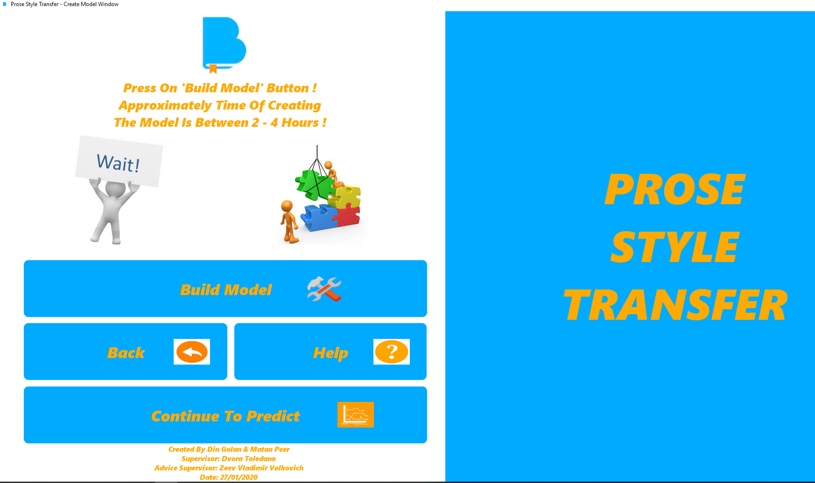

## Results Window –

* **‘Accuracy Between The Versions’ –**
* **In this result you will see the accuracy between the versions that the user / manager select.**
* **The Accuracy will represent in percent between 0%to – 100%.**
* **The compression is between the first bible version that the user / manager select and the second bible version that the user / manager select.**
* **‘Home Button’ –**
* **With this button you will go to the ‘Home Window’.**
* **If you are ‘User’ you will return to the ‘User Window’.**
* **If you are ‘Manager’ you will return to the ‘Manager Window’.**
* **‘Output Results’ –**
* **In this output you will see excel file that holds compressions between sentences from both versions that the user / manager select.**
* **In other words, you will see the maximum accuracy between sentences from both bible versions that the   
  user / manager select.**
* **Note – The selection of the versions will be done at ‘Select Source & Target Window’.**
* **‘Help Button’ –**
* **With this button you will get instructions about the system.**
* 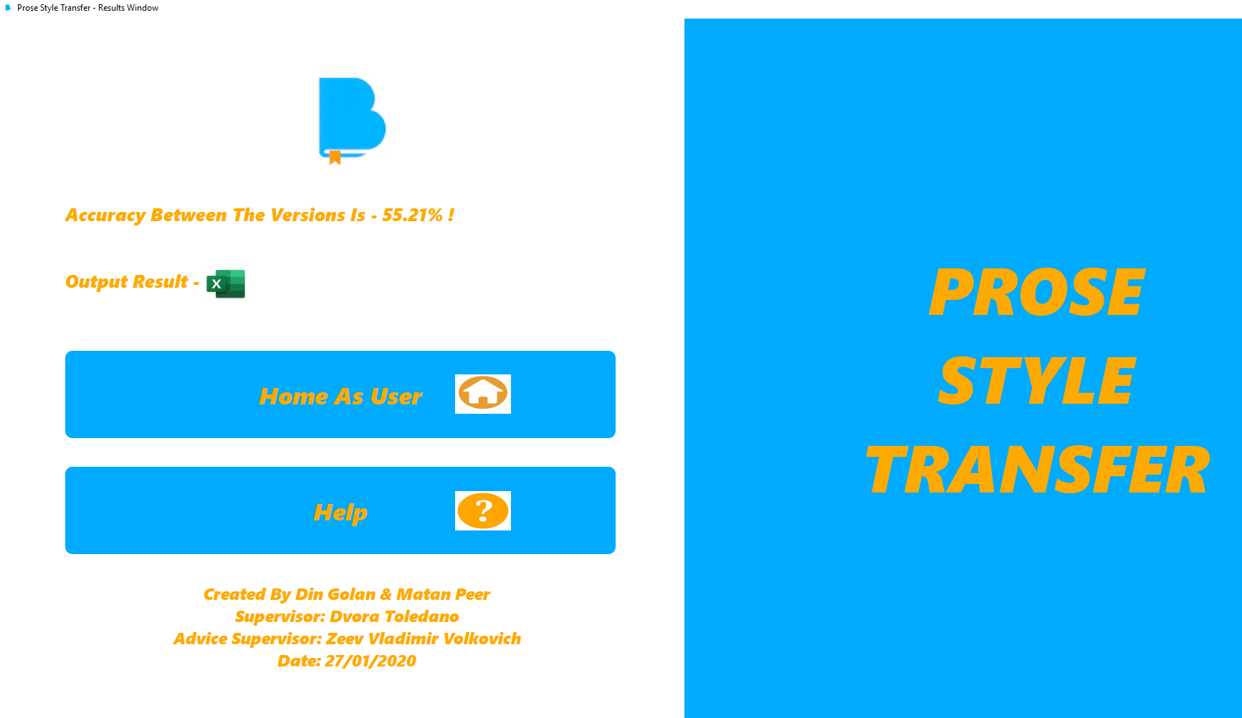**In addition, you will get explanations about each button in each window in the system.**

